St. Paul’s Lutheran Church Advent 1 November 30, 2025

Prelude

Ringing of the Bells

Announcements

Confession and Forgiveness
Blessed be the holy Trinity, ☩ one God, whose home is heaven and earth, whose salvation is sure.
C Amen.

Let us confess our sin in the presence of God and of one another.

Gracious God,
have mercy on us. We confess that we have turned from you and given ourselves into the power of sin. We are truly sorry and humbly repent. In your compassion forgive us our sins, known and unknown, things we have done and things we have failed to do. Turn us again to you, and uphold us by your Spirit, so that we may live and serve you in newness of life through Jesus Christ, our Savior and Lord.
Amen.

God judges us not as we deserve, but according to God’s own righteousness. ☩ You are freed and forgiven, saved by grace, and ready to welcome the Savior.
C Amen.

Greeting
The grace of our Lord Jesus Christ, the love of God, and the communion of the Holy Spirit be with you all.
C And also with you.

Kyrie
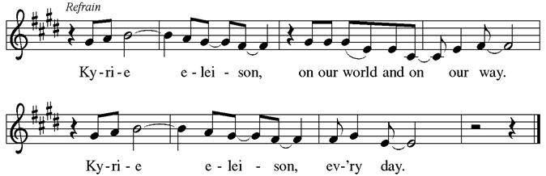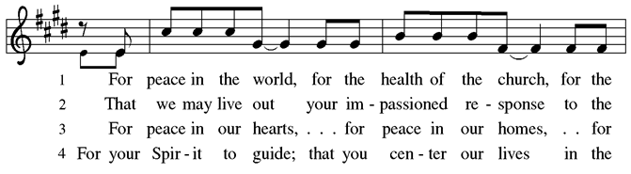

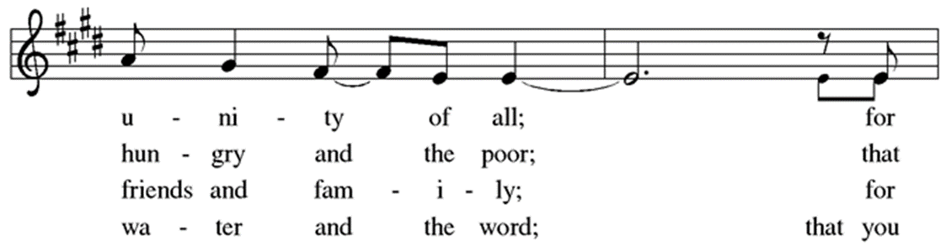
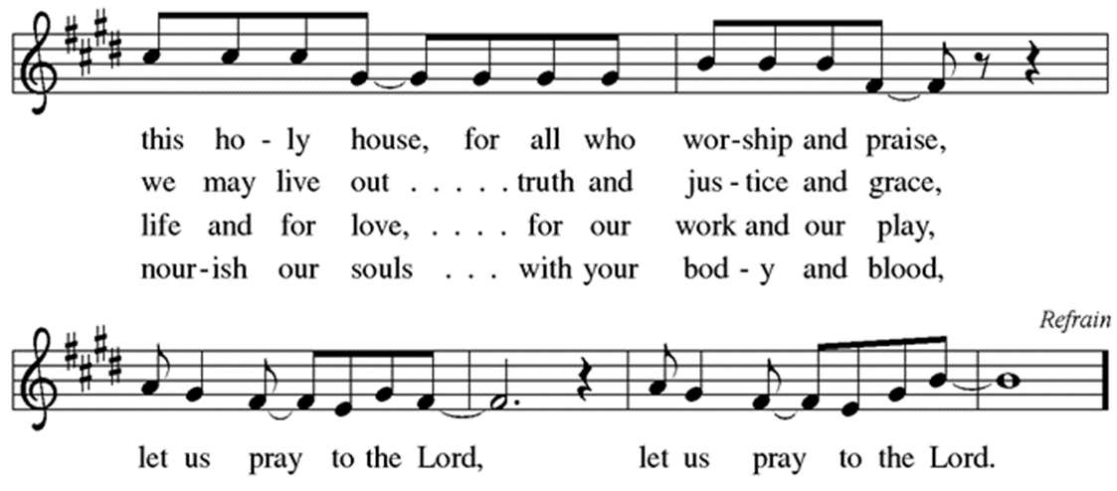

Hymn of Praise
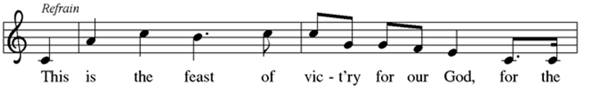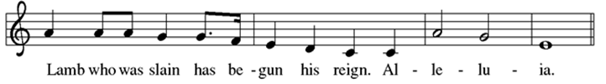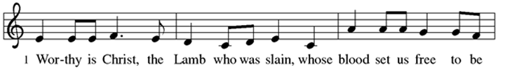
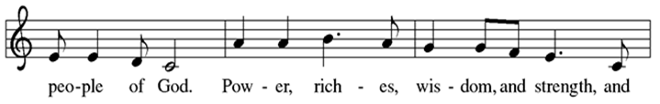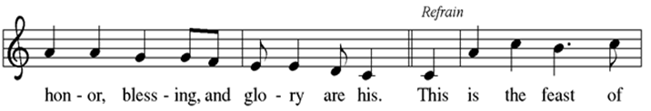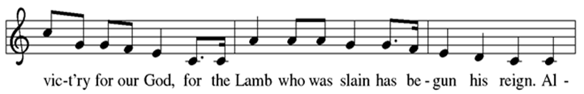
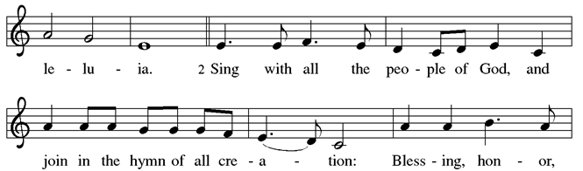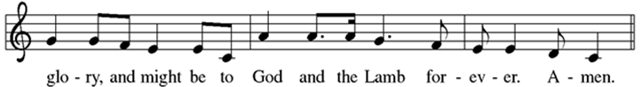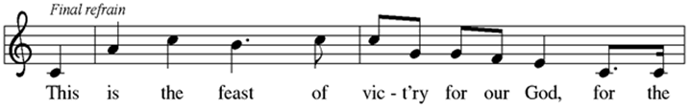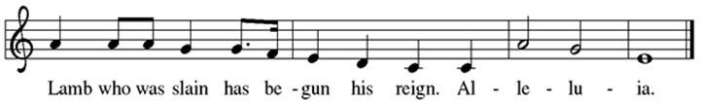

Prayer of the Day
Stir up your power, Lord Christ, and come. By your merciful protection save us from the threatening dangers of our sins, and enlighten our walk in the way of your salvation, for you live and reign with the Father and the Holy Spirit, one God, now and forever.
C Amen.
“Christ Be Our Light”
Lighting of the Advent Candle
(Justin & Jessie Lichlyter and Family)

Congregation Sings (Verse 1):
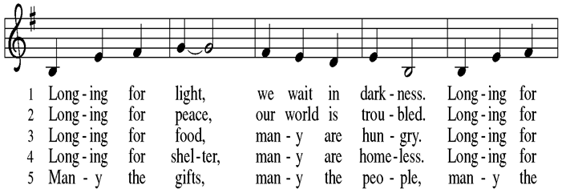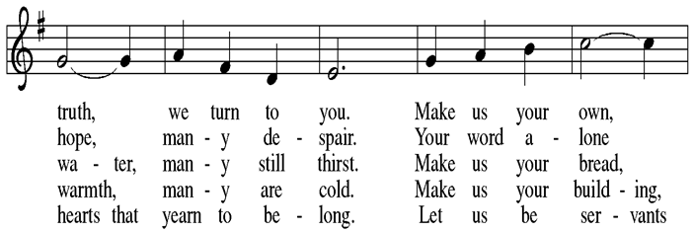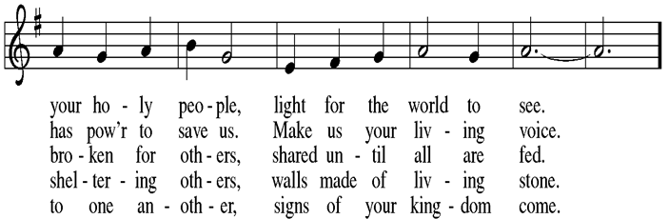
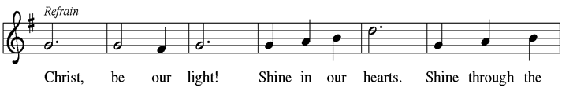
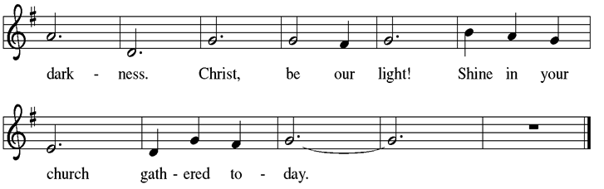

HOPE FOR THOSE WHO WAIT (Responsive Litany)

P Advent is a time for the human heart to wait, while trusting God’s eternal time.
C How long, O Lord, how long?

P For those waiting for answered prayer:
C Grant your steadfast patience.

P For those waiting in the face of uncertainty:
C Grant unshakable confidence in your sovereign provision.

P For those waiting for justice and mercy to reign:
C Grant a glimpse of your glory in our wounded world.

P For all of us waiting for God’s kingdom to come:
C Grant that we might have the peace of Christ as we wait, the love of Christ as we act, and the grace of Christ as we speak.

P This morning we light the first candle which reminds us that throughout history, God’s people have spent time waiting, wandering and wondering about the timing of God’s eternal plan. Like the people of old, we long for God’s presence to illuminate the areas of life where we are called to wait. This morning we echo the words of the Psalmist, “Wait for the Lord; be strong, and let your heart take courage; wait for the Lord!” (Psalm 27:14)

Congregation Sings:
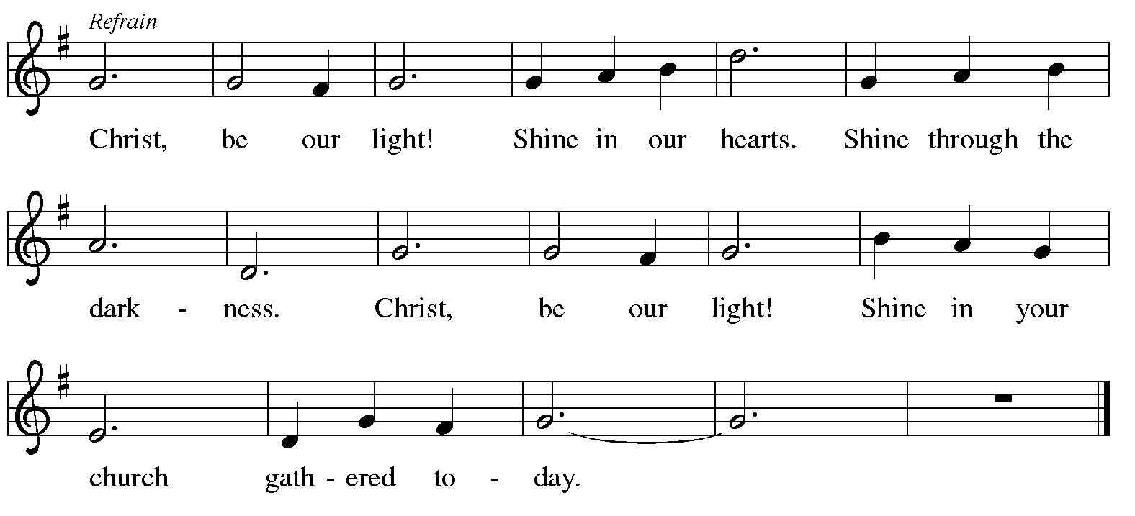

C Christ, Be Our Light! (sing)

CLOSING PRAYER

God of all creation, we declare that you are the Eternal One. We confess to you, O Lord, that we easily grow impatient, when your word to us is to wait. Ignite within us a new and everlasting hope. We pray this in the name of Christ, our Lord.
C Amen.

First Reading:

Genesis 30:1-2, 22-24 31:1-3, 22-32
¹ When Rachel saw that she bore Jacob no children, she envied her sister, and she said to Jacob, “Give me children, or I shall die!” ² Jacob became very angry with Rachel and said, “Am I in the place of God, who has withheld from you the fruit of the womb?” ²² Then God remembered Rachel, and God heeded her and opened her womb. ²³ She conceived and bore a son and said, “God has taken away my reproach,” ²⁴ and she named him Joseph, saying, “May the Lord add to me another son!” ¹ Now Jacob heard that the sons of Laban were saying, “Jacob has taken all that was our father’s; he has gained all this wealth from what belonged to our father.” ² And Jacob saw that Laban did not regard him as favorably as he did before. ³ Then the Lord said to Jacob, “Return to the land of your ancestors and to your kindred, and I will be with you.” ²² On the third day Laban was told that Jacob had fled. ²³ So he took his kinsfolk with him and pursued him for seven days until he caught up with him in the hill country of Gilead. ²⁴ But God came to Laban the Aramean in a dream by night and said to him, “Take heed that you say not a word to Jacob, either good or bad.” ²⁵ Laban overtook Jacob. Now Jacob had pitched his tent in the hill country, and Laban with his kinsfolk camped in the hill country of Gilead. ²⁶ Laban said to Jacob, “What have you done? You have deceived me and carried away my daughters like captives of the sword. ²⁷ Why did you flee secretly and deceive me and not tell me? I would have sent you away with mirth and songs, with tambourine and lyre. ²⁸ And why did you not permit me to kiss my sons and my daughters farewell? What you have done is foolish. ²⁹ It is in my power to do you harm, but the God of your father spoke to me last night, saying, ‘Take heed that you speak to Jacob neither good nor bad.’ ³⁰ Even though you had to go because you longed greatly for your father’s house, why did you steal my gods?” ³¹ Jacob answered Laban, “Because I was afraid, for I thought that you would take your daughters from me by force. ³² But anyone with whom you find your gods shall not live. In the presence of our kinsfolk, point out what I have that is yours, and take it.” Now Jacob did not know that Rachel had stolen the gods.
The word of the Lord.
C Thanks be to God.

Gospel ACCLAMATION (10 measures organ intro)
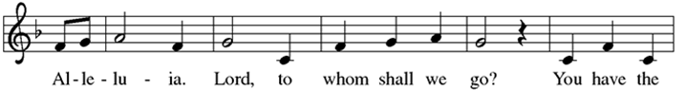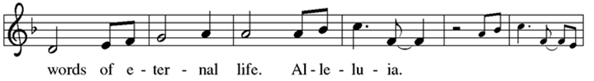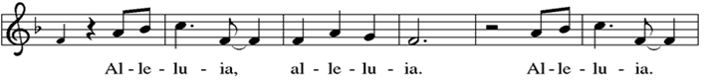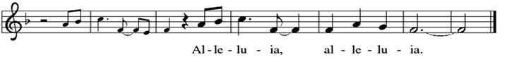

GOSPEL: Matthew 24:36-44

C Glory to you, O Lord.

[Jesus said to the disciples,] ³⁶ “About that day and hour no one knows, neither the angels of heaven, nor the Son, but only the Father. ³⁷ For as the days of Noah were, so will be the coming of the Son of Man. ³⁸ For as in the days before the flood they were eating and drinking, marrying and giving in marriage, until the day Noah entered the ark, ³⁹ and they knew nothing until the flood came and swept them all away, so, too, will be the coming of the Son of Man. ⁴⁰ Then two will be in the field; one will be taken, and one will be left. ⁴¹ Two women will be grinding meal together; one will be taken, and one will be left. ⁴² Keep awake, therefore, for you do not know on what day your Lord is coming. ⁴³ But understand this: if the owner of the house had known in what part of the night the thief was coming, he would have stayed awake and would not have let his house be broken into. ⁴⁴ Therefore you also must be ready, for the Son of Man is coming at an hour you do not expect.”

The gospel of the Lord.
C Praise to you, O Christ.
Sunday School Tone Chime Group

“Now Thank We All Our God”

Today we are blessed to hear our Sunday School tone chime group share their musical gifts. Thank you to Ashtyn Kalb, Ada Phillips, Evelyn Phillips, Frances Phillips, June Stemle, Maggie Stemle, and Rowan Werner.

Sermon Pastor Timothy Holt

Hymn of the Day

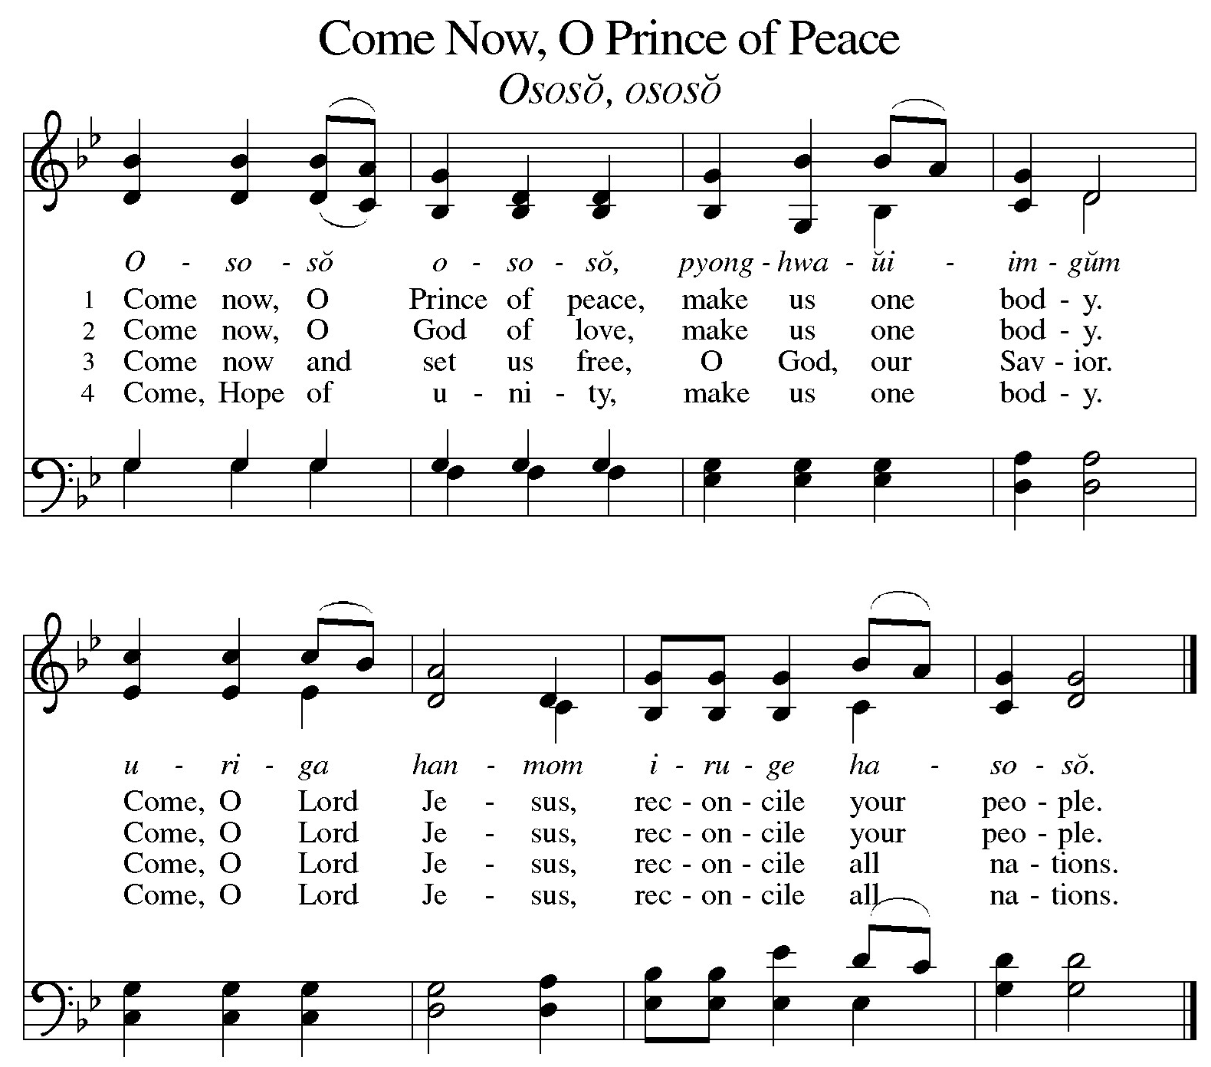

Apostle’s Creed
C I believe in God, the Father almighty, Creator
of Heaven and earth.

I believe in Jesus Christ, his only Son, our Lord. He was conceived by the power of the Holy Spirit and born of the Virgin Mary. He suffered under Pontius Pilate, was crucified, died, and was buried. He descended into hell. On the third day he rose again. He ascended into heaven, and is seated at the right hand of the Father. He will come again to judge the living and the dead.

I believe in the Holy Spirit, the holy catholic Church, the communion of saints, the forgiveness of sins, the resurrection of the body, and the life everlasting. Amen

Prayers of Intercession
In our waiting and watching, we come to you in prayer, O God, trusting your promise to renew the church, the nations, and the whole creation.

God of the people, we come seeking wisdom and instruction. Uphold and strengthen lay leaders, teachers, deacons, pastors, and bishops. Teach us your ways and lead us in your paths. God of grace,
C hear our prayer.

God of the earth, we seek your goodness in the grandeur of creation. Empower us to care for forests and oceans, as we see you in the world around us. God of grace,
C hear our prayer.

God of the nations, grant wisdom to leaders, judges, and mediators. Cast out words of hate and transform them into words for building up community. Remake implements of war to sow peace. God of grace,
C hear our prayer.

God of healing, bring comfort and strength. We pray for our kindred and companions who are ill or despairing. (We pray especially for Joe Alles, Zach Andry, Robin Bauer, Ron Bauer, Karen Bettag, Clint Breitweiser, Angie Danzer, Juanita Hembree, Brenda, Jean Hoffman, Lana Hoffman, Ann Hopf, Mary Ann Jerger, Katrina, Carol Keller, Tammy Kieffner, Karen Kolb, Zach Leinenbach, Bob Lottes, Zander Mann, Logan Musgrave, Pat Opel, Tammy Peek, Remington Rainey, Adam Ramsey, Steve Rothgerber, Melody Saylor, Annette Schepers, Glen Schmitt, Kaine Seitz, Larry Sendelweck, Makenzie VanHoy, and all those we name before you either silently or aloud.) Surround all with care and consolation. God of grace,
C hear our prayer.

We pray that you guide the military serving to protect us. Grant them safety and wisdom to carry out their assigned duties. (We pray especially for Austin Breitwieser, Luke Himsel and Cooper Uebelhor.) God of grace,
C hear our prayer.

God of all time, build up our lives that we would reflect your grace. At the last, bring us with all the saints to your holy city where peace and goodness make a home. God of grace,
C hear our prayer.

Draw near to us, O God, as we commend all for whom we pray, trusting in your mercy through Jesus Christ, Emmanuel.
C Amen.

Sharing of the Peace
The peace of Christ be with you always.
C And also with you.

Offering of our tithes and gifts

Offertory

Offertory Response
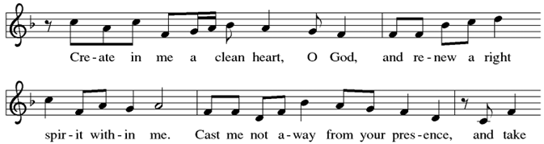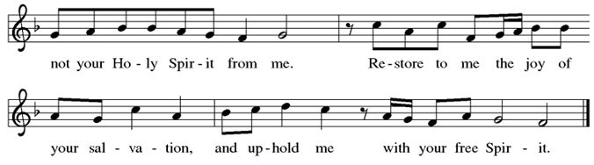

Offering Prayer

Let us pray.
C Blessed are you, O God, source of every gift of your creation. By these gifts and with our lives, help us to serve one another and all in need, through Jesus Christ, our Savior and Lord.
Amen.

Instructions for Communion
All who are baptized are welcome to receive Holy Communion. Children who have not yet received instruction about Holy Communion are invited to come forward for a blessing. As you approach the communion assistant, the first will hand you the bread. Take and eat it. Then take a communion cup from the tray. After you have taken the wine, place your empty cup in the tray table beside the pillar.

Dialogue
The Lord be with you.
C And also with you.

Lift up your hearts.
C We lift them to the Lord.

Let us give thanks to the Lord our God.
C It is right to give our thanks and praise.

PREFACE
It is indeed right and salutary that we should at all times and in all places offer thanks and praise to you, O Lord, holy Father, through Christ our Lord; who on this day overcame death and the grave, and by his glorious resurrection opened to us the way of everlasting life. And so, with the Church on earth and the hosts of heaven, we praise your name and join their unending hymn:

Sanctus

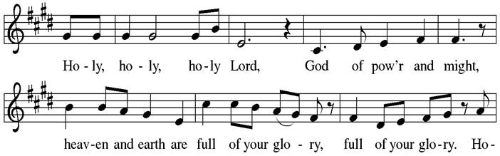
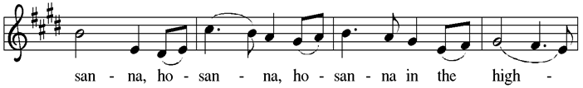
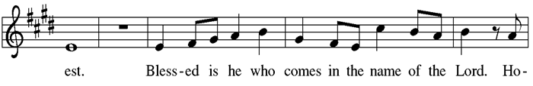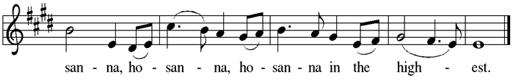

Eucharistic Prayer

In the night in which he was betrayed, our Lord Jesus took bread, and gave thanks; broke it, and gave it to his disciples, saying:

Take and eat; this is my body, given for you.
Do this for the remembrance of me.

Again, after supper, he took the cup, gave thanks, and gave it for all to drink, saying:

This cup is the new covenant in my blood, shed for you and for all people for the forgiveness of sin. Do this for the remembrance of me.

The Lord’s Prayer

C Our Father, who art in heaven, hallowed be thy name, thy kingdom come, thy will be done, on earth as it is in heaven. Give us this day our daily bread; and forgive us our trespasses, as we forgive those who trespass against us; and lead us not into temptation, but deliver us from evil. For thine is the kingdom, and the power, and the glory, forever and ever. Amen.

Communion

The body of Christ, given for you. Amen.
The blood of Christ, shed for you. Amen.

LAMB OF GOD

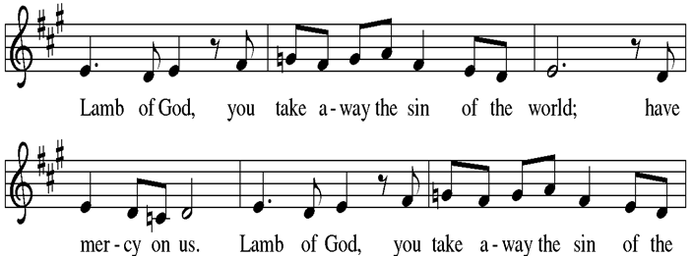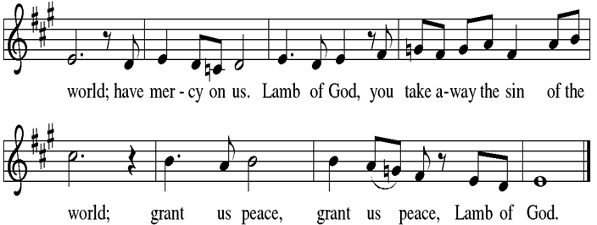

Communion Hymns

LBW 33 “The King Shall Come”
LBW 32 “Fling Wide the Door”
LBW 22 “The Advent of Our God”

The body and blood of our Lord Jesus Christ strengthen you and keep you in his grace.
C Amen.

post communion canticle
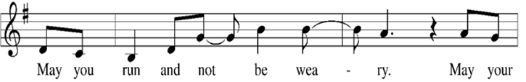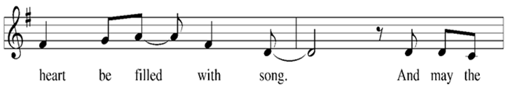
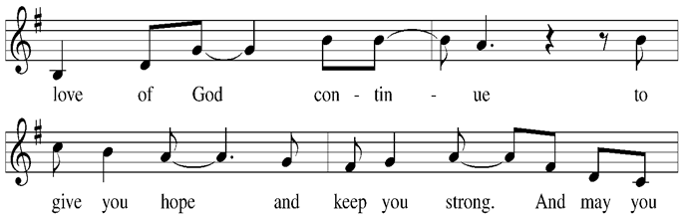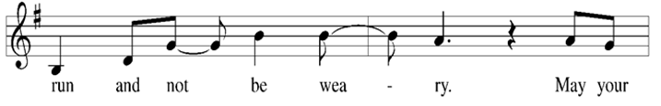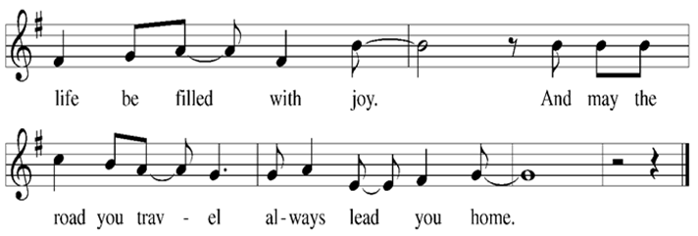
Prayer after Communion

Let us pray
C Holy God, you have welcomed us to this meal
and fed us with dignity at your table. Send us now to welcome others and to be at peace with one another, through Jesus Christ our Lord. Amen.

Blessing
May God who comes among us, Father, ☩ Son, and Holy Spirit, grant you patience in waiting, peace in the darkness, and good news to share today and always.
C Amen.

Sending Hymn
LBW 25 “Rejoice, Rejoice, Believers”

Dismissal
Go in peace. Follow Jesus.
C Thanks be to God.

POSTLUDE

Mission Statement: Worship Boldly, Empower for Discipleship,
Cultivate Spiritual Maturity, Strengthen Community, Serve.
Thank you to the following people for your service today:

Greeters: Judy Wessel and Jill Wagner
Comm. Asst: Mike Weisheit
Video: Jeff Schmitt
Organist: Barb Dell
Lay Reader: Erin Kalb
Audio: Bryan Buchta
Acolytes: Kix Smith and Hudson Stemle

aTTENDANCE last sunday: 185 ss: 17

CALENDAR FOR THE WEEK OF
Nov. 30th – Dec 7th

Sun. Nov. 30th 8:00 AM Chancel Choir Practice
9:00 AM Sunday Worship Service
(Sunday School Christmas Program Practice – after communion until 11:00 AM)

Tues. Dec. 2nd 6:00 PM WELCA Christmas Carry-in meal & program

Wed. Dec. 3rd 6:30 PM Handbell Practice
6:30 PM Confirmation

Sun Dec. 7th 8:00 AM Chancel Choir
9:00 AM Sunday Worship Service
(Sunday School Christmas Program Practice – after communion until 11:00 AM)
ST. PAUL’S ANNOUNCEMENTS

Today is the last day Christmas Poinsettias  will be for sale before and after service in the entance area. The cost is $14.50 each. – Dian Bair

Annual reports for each committee will need to be dropped in office or emailed to Marcie at secretaryst.paul@frontier.com no later than December 7th. Contact Marcie if you need assistance.

CEMETERY DUES REMINDER: Active members, desiring burial rights, are required to pay cemetery dues of a minimum of twenty dollars per family. This includes all members in immediate family, including non-member spouses, and children under the age of eighteen. Every member over eighteen years of age shall be required to pay the minimum cemetery dues as an individual. No additional charge for gravesites shall be made to members of St. Paul’s whose dues are current. - Marvin, Tom, or Harvey

Thankoffering envelopes will be available at the Welcome Center desk. They can be placed in the offering plate at any time through the end of November. These offerings will be submitted to the Synod office. Please help us to show our gratitude for God's many Blessings. Thank you!
-Darlene Ziegler

The Evangelism committee has put together an angel tree for local children who might otherwise go without on Christmas. The children range from the age of 3 through 18. Anyone is welcome to adopt/sponsor a child, you could do it solely, with your extended family or with another family. We are just asking that you spend approximately $100 on the child’s needs. The Evangelism Committee will have a tree setup for your choosing, along with a donation box if you would rather donate money and the committee will do the shopping for you. All donations must be turned in on or before December 7th. See Julie Breitwieser with questions

LYO Christmas Caroling – Sunday, December 7th
Join the LYO for Christmas caroling on Sunday, December 7th! We will meet at Brookside Village at 11:15 a.m. to allow our Sunday School kids to sing with us after their Christmas program practice. We’ll be spreading Christmas cheer at Brookside Village, Northwood Good Samaritan (nursing home & assisted living), and The Timbers. Wear your favorite Christmas gear or your best ugly sweater and come be part of the fun! We invite everyone to join us as we share the joy of the season!!! – Tara Betz


St. Paul’s will be collecting food items for our local food bank during the month of December. This would be a great way to get the whole family involved in giving this Christmas season. Create a box for the whole month or add single items to the grocery cart in the welcome center. See the Reverse Advent
calendar for a list. -Donna Rasche


